This is a plain Maven project (not Spring Boot), so Spring doesn't automatically detect the controller. Tomcat handles servlet execution but requires explicit mapping.
We use the DispatcherServlet as a front controller to route these requests properly.
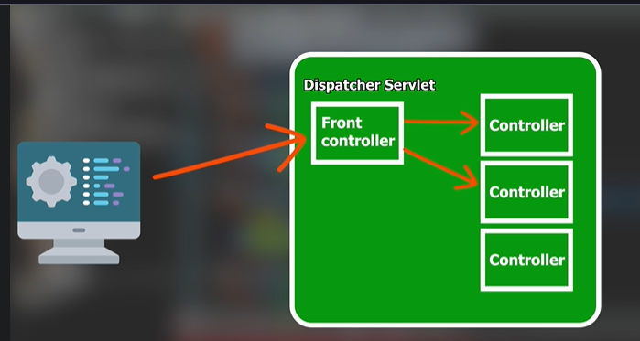

Spring has a dispatcher servlet and we just have to configure it. Whenever we run a project using tomcat, first it goes to the web.xml file.
In web.xml we will map or declare our dispatcher-servlet. 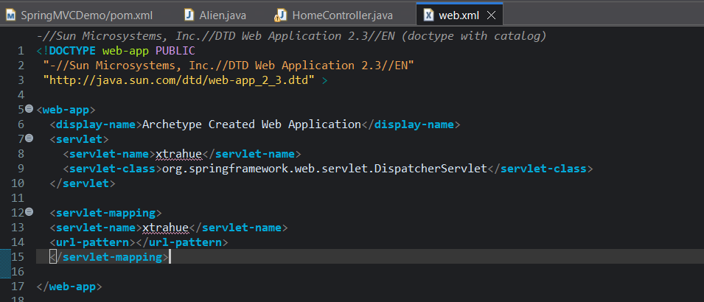
web.xml (Tomcat configuration): Your web.xml tells Tomcat:
- "Whenever a request comes in, create a DispatcherServlet named xtrahue."
- There is no information here about:
  - where controllers are
  - where JSPs are
  - which package to scan
  - ViewResolver
  - Spring Beans
- It only says: Instantiate DispatcherServlet.

Even after configuring web.xml, still if we run our server we will get below error: 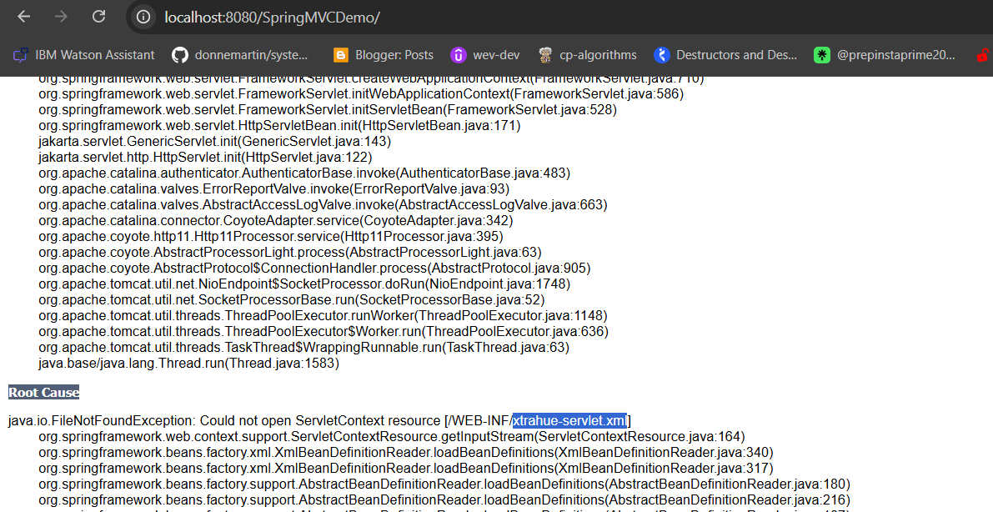

Tomcat
│
▼
web.xml
│
▼
DispatcherServlet created
│
▼
DispatcherServlet asks
"Where is my Spring configuration?"
│
▼
Looks for
WEB-INF/xtrahue-servlet.xml
│
▼
File doesn't exist
│
▼
Application startup fails

Now we need to create the xtrrahue-servlet.xml: 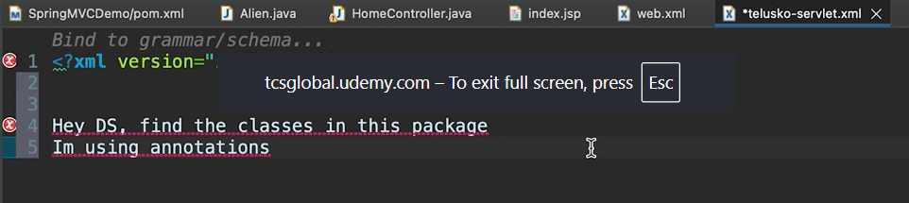
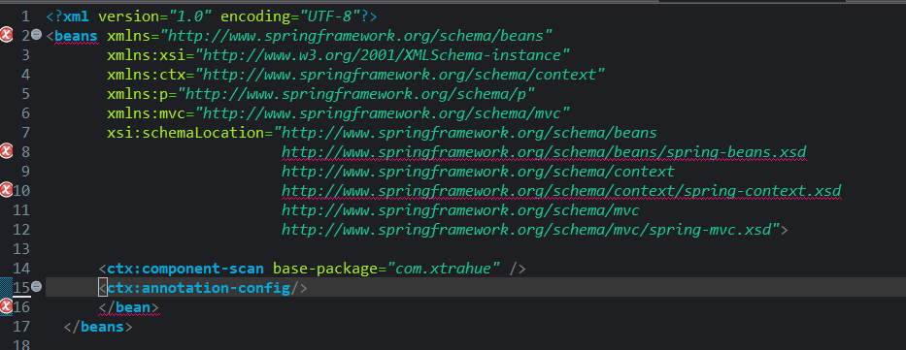
Ctx implements the above image.

Still no screen appears, cause in the springboot, we mentioned the location where the view files are located and what is the extension of the view technology(prefix and suffix). Here we haven’t done any such thing yet. We will do that here by the help of: InternalResourceViewResolver .
So, we are going to mention this also in xtrahue-servlet.xml:
<?xml version="1.0" encoding="UTF-8"?>
<beans xmlns="http://www.springframework.org/schema/beans"
xmlns:xsi="http://www.w3.org/2001/XMLSchema-instance"
xmlns:ctx="http://www.springframework.org/schema/context"
xmlns:p="http://www.springframework.org/schema/p"
xmlns:mvc="http://www.springframework.org/schema/mvc"
xsi:schemaLocation="http://www.springframework.org/schema/beans
http://www.springframework.org/schema/beans/spring-beans.xsd
http://www.springframework.org/schema/context
http://www.springframework.org/schema/context/spring-context.xsd
http://www.springframework.org/schema/mvc
http://www.springframework.org/schema/mvc/spring-mvc.xsd">

<ctx:component-scan base-package="com.xtrahue" />
<ctx:annotation-config/>

<bean class="org.springframework.web.servlet.view.InternalResourceViewResolver">
<property name="prefix" value="/views/"></property>
<property name="suffix" value=".jsp"></property>
</bean>
</beans>

